CENTRAL WEST LAW SOCIETY
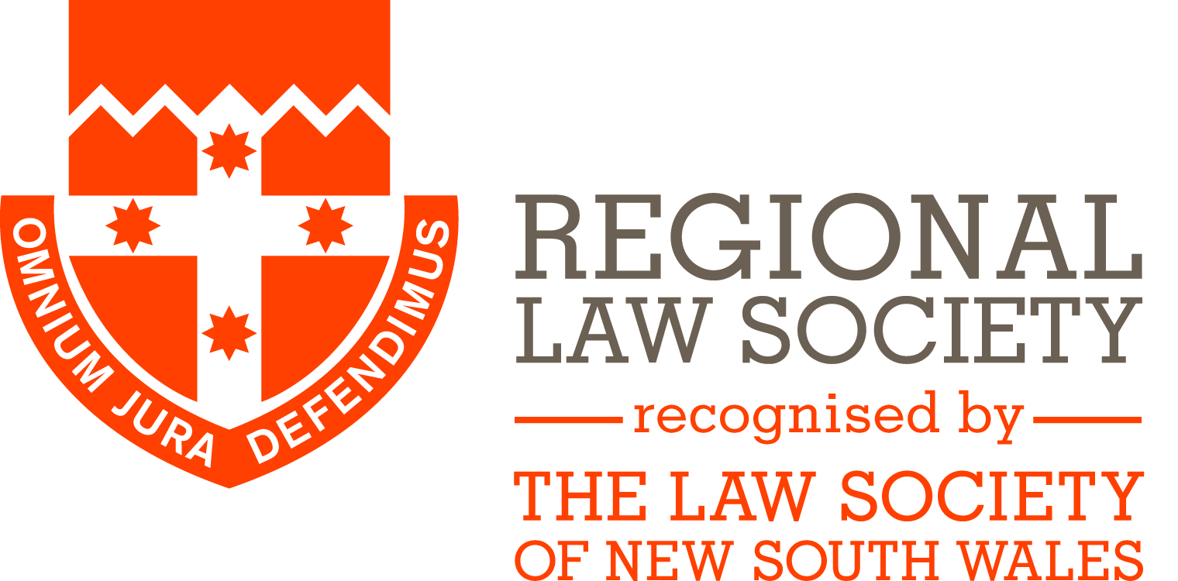

APPLICATION FOR BURSARY AND STUDENT PRIZE 2021

Applicants must meet the following criteria:
- Work in a law firm or government department in the Central West Law Society region; and
- Studying an accredited law degree at an Australian University or College of Law or Solicitors Admission Board course (including PLT courses but excluding Masters or PhD studies).
The CWLS Bursary is open to students who work in a Central West firm / department full time or part time on a permanent basis whilst undertaking their study. The Bursary Fund is up to a potential maximum of $2,500 per annum, with the total sum to be awarded in each year, and the division of funds between successful applicants, to be determined by the Bursary Committee.
The CWLS student prize is open to students who work in a Central West firm / department on a casual or temporary basis during their studies. Applicants must show some period of employment or unpaid work experience in the year 1 March 2020 to 28 February 2021. The successful applicant(s) will receive up to a potential $500. This amount may be divided between multiple applicants at the discretion of the Bursary Committee.
Previous recipients are eligible to re-apply
Applicants for the Bursary and Student Prize will be considered on the following criteria:
- Personal circumstances including hardship
- Academic merit
- Receipt of any previous CWLS bursary/prize funds
Applications close Friday 26 March 2021

FULL NAME: ………………………………………………………………………
ADDRESS: ………………………………………………………………………
………………………………………………………………………
EMAIL: ………………………………………………………………………
EMPLOYER: ………………………………………………………………………
INSTITUTION / COURSE: ………………………………………………………
………………………………………………………………………
APPLICATION FOR: __ Bursary OR ___ Student Prize
Please attach:
- Confirmation of enrolment for 2021;
- Proof of employment / work experience;
- Academic results for subjects completed (for 2nd or later year students); and
- Brief outline of personal circumstances [no more than one typed page] (relevant information includes financial circumstances, family situation, community involvement and/or difficulties relating to studies).

Return to:
Central West Law Society
PO Box 33
BATHURST NSW 2795

